1)

#include<iostream>

#include<vector>

#include<algorithm>

using namespace std;

int n,m;

int countt=0;

#define CN countt++

int p[100],w[100];

struct PW

{

vector <pair<int,int>>S;

}X[100];

void display_pair(vector <pair<int,int>> x)

{

vector <pair<int,int>> :: iterator it;

for(it=x.begin();it!=x.end();++it)

{

cout<<"{"; cout<<(*it).first;

cout<<",";

cout<<(*it).second;cout<<"} ";

}

cout<<endl;

}

void purge()

{

vector <pair<int,int>>:: iterator i;

vector <pair<int,int>>:: iterator j;

for(int k=1;k<=n;k++)

{

for(i=X[k].S.begin(); i!= X[k].S.end();++i)

{

CN;

for(j=i+1; j!= X[k].S.end();++j)

{

CN;

if((*i).first<=(*j).first && (*i).second >= (*j).second)

{CN;X[k].S.erase(i--);j--;CN;}

}

}

}

}

bool PairMatch(vector <pair<int,int>> z, int pp, int ww)

{

vector <pair<int,int>> :: iterator zi;

for(zi=z.begin(); zi!=z.end(); ++zi)

{

CN;

if((*zi).first==pp && (*zi).second== ww)

{CN; return true;CN;}

}

return false;

}

void traceBack()

{

vector <pair<int,int>> :: iterator it;

vector <pair<int,int>> :: iterator c;

int solVect[n+1];

it=max_element(X[n].S.begin(),X[n].S.end());CN; //Find the largest pair

int pp=(*it).first; int ww=(*it).second;CN;

cout<<"MAX PROFIT: "<<pp<<endl;

cout<<"TOTAL WEIGHT OCCUPIED: "<<ww<<endl;

for(int p=0; p<n;p++)

{

solVect[p]=0;

}

//Start from the n-1 set

for(int i=n-1;i>=0;i--)

{

CN;

bool status=PairMatch(X[i].S,pp,ww);CN;//check if the set is present or no

if(status)

{

CN;

solVect[i]=0;CN;

}

else

{

solVect[i]=1;CN;

pp=pp - p[i];CN;

ww=ww - w[i];CN;

}

}

cout<<"SOLUTION VECTOR: {";

for(int p=0; p<n;p++)

{

CN;

cout<<solVect[p];CN;

if(p!=n-1) cout<<",";

}cout<<"}"<<endl;

}

void Dk()

{

//S0 initially;

vector <pair<int,int>> :: iterator it;

X[0].S.push_back(make_pair(0,0));CN;

int next=1; //next is S1...

for(int i=0;i<n;i++)

{

CN;

for(it=X[next-1].S.begin();it!=X[next-1].S.end();++it) //Merge previous S1n-1

{

CN;

X[next].S.push_back(make_pair((*it).first,(*it).second));CN;

}

for(it=X[next-1].S.begin();it!=X[next-1].S.end();++it) //Calculate the remaining and merge

{

CN;

if(((*it).second)+w[i] > m)

{CN;continue;}

X[next].S.push_back(make_pair(((*it).first+p[i]),((*it).second)+w[i]));CN;

};

next++;CN;

}

purge();cout<<endl;CN;

for(int k=0;k<=n;k++) //Display the subsets

{

CN;

cout<<"S"<<k<<": ";CN;

display_pair(X[k].S);CN;

cout<<endl;

}

traceBack();

}

int main()

{

cout<<"ENTER NUMBER OF ELEMENTS : ";

cin>>n;

cout<<"ENTER PROFIT AND WEIGHT OF ELEMENTS: "<<endl;

for(int i=0;i<n;i++)

{

cin>>p[i]>>w[i];

}

cout<<"ENTER THE BAG CAPACITY : ";

cin>>m;

Dk();

cout<<"\nSTEP COUNT: "<<countt;

}

OUTPUT

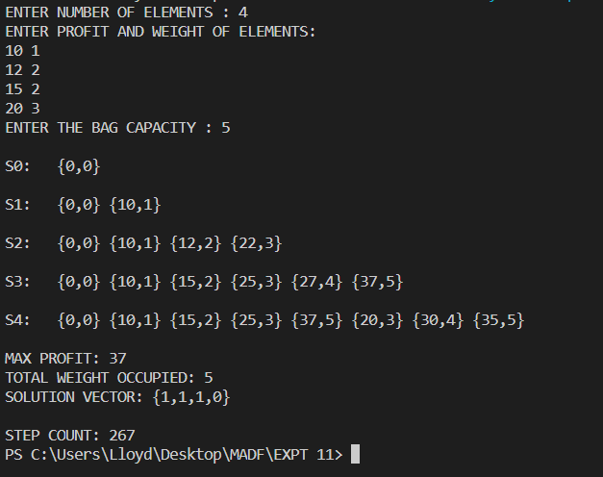

1)

#include<iostream>

#include<math.h>

#include<iomanip>

#define MAX 10

#define CNT cntt++

using namespace std;

int outcome[MAX],n,count=0,cntt=0;

int TupleDATABASE[1000][MAX],dataBcnt=1;

void printChessboard()

{

int x;

cout<<"ENTER INDEX NUMBER OF THE TUPLE TO BE PRINTED: ";

cin>>x;cout<<endl;

int i,j;

for(i=1;i<=n;i++)

{

for(j=1;j<=n;j++)

{

if(TupleDATABASE[x][i]==j)

cout<<"Q"<<" ";

else

cout<<"^"<<" ";

}

cout<<endl;

}

}

void Print_Outcome()

{

cout<<setw(4)<<++count<<"| "<<"{";

int i,j;

for(i=1;i<=n;i++,j++)

{

TupleDATABASE[dataBcnt][i]=outcome[i];

cout<<outcome[i];

if(i!=n)

cout<<",";

}

cout<<"} ";

dataBcnt++;

if(count%2==0)

cout<<endl;

}

bool Place(int k,int i)

{

int j;

for(j=1;j<=k-1;j++)

{

CNT;

if(outcome[j]==i || abs(outcome[j]-i)==abs(j-k))

{CNT;return false;}

}

return true;

}

void NQueens(int k,int n)

{

int i;

for(i=1;i<=n;i++)

{

CNT;

if(Place(k,i))

{

CNT;

outcome[k]=i;CNT;

if(k==n)

{CNT;Print_Outcome();}

else

{CNT;NQueens(k+1,n);}

}

}

}

void setPrint()

{

int i;

cout<<" {";

for(i=1;i<=n;i++)

{

cout<<"X"<<i;

if(i!=n)

cout<<",";

}

cout<<"} "<<endl;

}

int main()

{

int choice;

cout<<"ENTER VALUE OF N: ";

cin>>n;

cout<<endl<<" POSSIBLE SOLUTIONS";

setPrint();cout<<endl;

NQueens(1,n);

cout<<"STEP COUNT: "<<cntt<<endl;

while(1)

{

cout<<"\n\n________________________OPTIONS___________________________\n";

cout<<"PRESS 1: TO PRINT CHESSBOARD REPRESENTATION OF ANY TUPLE\n";

cout<<"PRESS 2: TO EXIT\n";

cout<<"ENTER YOUR CHOICE: ";

cin>>choice;

switch(choice)

{

case 1:printChessboard();break;

case 2: return 0;

}

}

}

OUTPUT

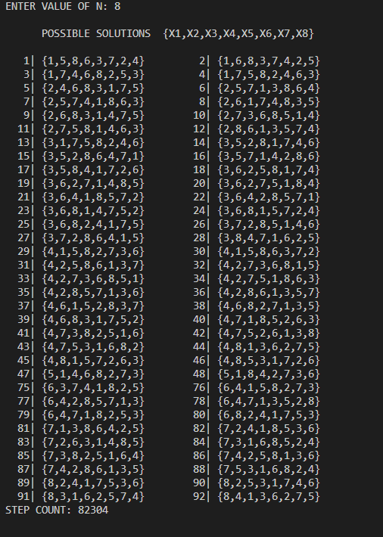

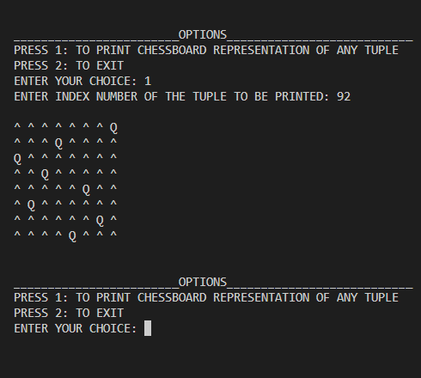

1)

#include<iostream>

#include<iomanip>

#define CNT cntt++

using namespace std;

int n,m,cntt=0;

void whitespace(int x)

{

for(int i=0;i<x;i++)

cout<<" ";

}

void print_solTup(int elements[],int solTup[], int k)

{

int i;

cout<<"{";

for(i=1;i<=k;i++)

{

cout<<solTup[i];CNT;

if(i!=k)

cout<<",";

}

cout<<"} ";

//i represents no. of spaces elements occupied on the screen

whitespace(30-((i*2)+1)); //x2 No 0f elements,commas and brackets combined

cout<<"[";

for(i=1;i<=k;i++)

{

if(solTup[i]==1)

cout<<elements[i];

if(i!=k&&solTup[i]==1)

cout<<",";

}

cout<<"] ";

cout<<endl;

}

void sum_of_subsets(int elements[],int solTup[],int s, int k, int r)

{

if(k>n)

return;

solTup[k]=1;CNT;

if(s+elements[k]==m)

{CNT;print_solTup(elements,solTup,k);CNT;}

else if((s+elements[k]+elements[k+1])<=m)

{CNT;sum_of_subsets(elements,solTup,s+elements[k],k+1,r-elements[k]);CNT;}

if((s+r-elements[k]>=m) && (s+elements[k+1]<=m))

{

CNT;

solTup[k]=0;CNT;

sum_of_subsets(elements,solTup,s,k+1,r-elements[k]);CNT;

}

}

int main()

{

int r=0,i;

cout<<"ENTER THE SIZE OF THE SET"<<endl;

cin>>n;

int elements[n+1];

int solTup[n+1];

cout<<"ENTER ELEMENTS INTO YOUR ARRAY:\n";

for(i=1;i<=n;i++)

{

cin>>elements[i];

solTup[i]=0;

r+=elements[i];

}

cout<<"ENTER TARGET SUM: ";

cin>>m;cout<<endl;

cout<<std::left<<setw(30)<<"TUPLE"<<std::left<<setw(30)<<"ELEMENTS: "<<endl;

sum_of_subsets(elements,solTup,0,1,r);

cout<<"\nSTEP COUNT: "<<cntt<<endl;

return 0;

}

OUTPUT

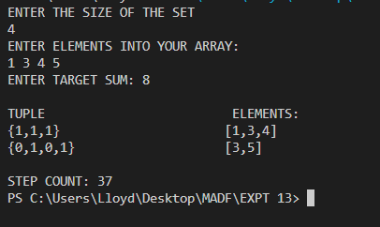

1)

#include<iostream>

#include<windows.h>

using namespace std;

#define MAX 10

#define NEXTLINE cout<<"\n"

#define CNT count++

int GRAPH[MAX][MAX],Colors[MAX];

int V,E,M;

int count=0;

enum ColourScheme{BLUE=1,GREEN,CYAN,RED,PURPLE,YELLOW,};

void Line_Generator(int n)

{

int i;

for(i=0;i<n;i++)

cout<<"-";

}

void G_create()

{

int i,j;

cout<<"ENTER NUMBER OF VERTICES:\n";

cin>>V;

cout<<"ENTER NUMBER OF COLOURS:\n";

cin>>M;

cout<<"ENTER ADJACENCY MATRIX:\n";

for(i=0;i<V;i++)

for(j=0;j<V;j++)

{

cin>>GRAPH[i][j];

}

for(i=0;i<V;i++)

Colors[i]=0;

}

void SetColor(int value){

SetConsoleTextAttribute(GetStdHandle(STD_OUTPUT_HANDLE), value);

}

void print_Coloured_Graph()

{

int i;

for(i=0;i<V;i++)

{

if(Colors[i]==1)

SetColor(RED);

if(Colors[i]==2)

SetColor(BLUE);

if(Colors[i]==3)

SetColor(GREEN);

if(Colors[i]==4)

SetColor(YELLOW);

if(Colors[i]==5)

SetColor(CYAN);

if(Colors[i]==6)

SetColor(PURPLE);

cout<<Colors[i]<<" ";

}

NEXTLINE;

}

void NextValue(int k)

{

while(1)

{

Colors[k]=(Colors[k]+1)%(M+1);CNT;

if(Colors[k]==0)

{CNT;return;}

int j;

for(j=0;j<V;j++)

{

if(GRAPH[k][j]!=0 && Colors[j]==Colors[k])

{CNT;break;}

}

if(j==V)

{CNT;return;}

}

}

void m_coloring(int k)

{

while(1)

{

CNT;NextValue(k);CNT;

if(Colors[k]==0)

{CNT;return;}

if(k==V-1)

{CNT;print_Coloured_Graph();}

else

{ m_coloring(k+1);CNT;}

}

}

int main()

{

G_create();

cout<<"\n\n****** |COLOURED GRAPH| ******\n";

cout<<"-------------------------------\n";

cout<<"Red|Blue|Green|Yellow|Cyan|Purple\n";

cout<<" 1 | 2 | 3 | 4 | 5 | 6 \n\n";

for(int i=0;i<V;i++)

{cout<<"["<<i+1<<"]"<<" ";}

cout<<endl;

Line_Generator((V*6)+3);

cout<<endl;

m_coloring(0);

cout<<"STEP COUNT: "<<count<<endl;

}

OUTPUT

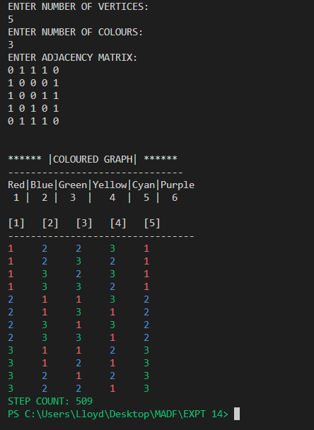

1)

#include<iostream>

#include<windows.h>

#define RED 4

#define WHITE 7

#define CNT cntt++

using namespace std;

int m,n,cntt=0;

void SetColor(int value){

SetConsoleTextAttribute(GetStdHandle(STD_OUTPUT_HANDLE), value);

}

void HighlightPattern(int i,string text,string pattern)

{

cout<<"\n\nPATTERN MATCHED!"<<endl;

//substr() used to slice the string for colouring

cout<<text.substr(0,i);

SetColor(RED);

cout<<text.substr(i,m);

SetColor(WHITE);

cout<<text.substr(i+m,n);

cout<<endl<<"FROM: "<<i+1<<" TO "<<i+m;

}

int BruteForce_patternMatching(string text, string pattern)

{

int j;

for(int i=0;i<=n-m;i++)

{

CNT;

j=0; CNT;

while(j<m && text[i+j]==pattern[j])

{

CNT; j++; CNT;

}

if(j==m)

{ CNT;return i;}

}

cout<<"NO SUBSTRING PRERSENT!"; CNT;

cout<<"\nSTEP COUNT: "<<cntt;

exit(0);

}

int main()

{

string text,pattern;int i;

cout<<"ENTER A STRING: ";

getline(cin,text);

n=text.length();

cout<<"ENTER PATTERN STRING: ";

getline(cin,pattern);

m=pattern.length();

HighlightPattern(BruteForce_patternMatching(text,pattern),text,pattern);

cout<<"\nSTEP COUNT: "<<cntt;

}

OUTPUT

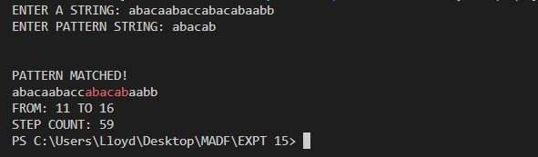

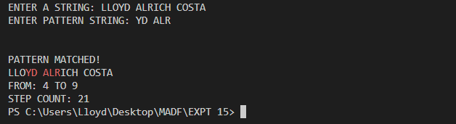

2)

#include<iostream>

#include<windows.h>

#include<algorithm>

#include<string>

#define CNT cntt++

#define RED 4

#define WHITE 7

using namespace std;

int m,n,cntt=0;

void SetColor(int value){

SetConsoleTextAttribute(GetStdHandle(STD_OUTPUT_HANDLE), value);

}

void HighlightPattern(int i,string text,string pattern)

{

cout<<"\n\nPATTERN MATCHED!"<<endl;

//substr() used to slice the string for colouring

cout<<text.substr(0,i);

SetColor(RED);

cout<<text.substr(i,m);

SetColor(WHITE);

cout<<text.substr(i+m,n);

cout<<endl<<"FROM: "<<i+1<<" TO "<<i+m;

}

int last(string pattern,char c)

{

int L=pattern.find_last_of(c);

if(L!=string::npos)

return L;

else

return -1;

}

int BMmatch(string text, string pattern)

{

int i=m-1;CNT;

int j=m-1;CNT;

do{

CNT;

if(pattern[j]==text[i])

{

CNT;

if(j==0)

{CNT;return i;}

else

{

i--;CNT;

j--;CNT;

}

}

else

{

i=i+m-min(j,1+last(pattern,text[i]));CNT;

j=m-1;CNT;

}

}while(i<=n-1);

cout<<"NO SUBSTRING PRERSENT!";

cout<<"\nSTEP COUNT: "<<cntt;

exit(0);

}

int main()

{

string text,pattern;int i;

cout<<"ENTER A STRING: ";

getline(cin,text);

n=text.length();

cout<<"ENTER PATTERN STRING: ";

getline(cin,pattern);

m=pattern.length();

HighlightPattern(BMmatch(text,pattern),text,pattern);

cout<<"\nSTEP COUNT: "<<cntt;

}

OUTPUT

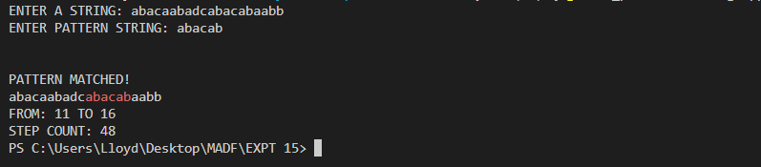

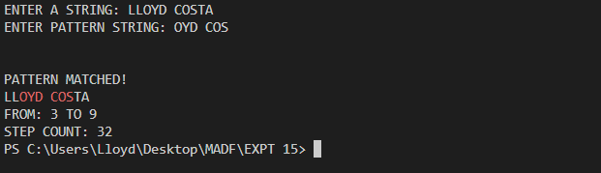

1)

#include<iostream>

#include<windows.h>

#include<algorithm>

#include<string>

#define CNT cntt++

#define RED 4

#define WHITE 7

using namespace std;

int m,n,f[200],cntt=0;

void SetColor(int value){

SetConsoleTextAttribute(GetStdHandle(STD_OUTPUT_HANDLE), value);

}

void HighlightPattern(int i,string text,string pattern)

{

cout<<"\n\nPATTERN MATCHED!"<<endl;

//substr() used to slice the string for colouring

cout<<text.substr(0,i);

SetColor(RED);

cout<<text.substr(i,m);

SetColor(WHITE);

cout<<text.substr(i+m,n);

cout<<endl<<"FROM: "<<i+1<<" TO "<<i+m;

}

void KMPFailureFunction(string pattern)

{

int i=1,j=0;

f[0]=0;CNT;

while(i<m)

{

CNT;

if(pattern[j]==pattern[i])

{

CNT;

f[i]=j+1;CNT;

i++;CNT;

j++;CNT;

}

else if(j>0)

{

j=f[j-1];CNT;

}

else

{

f[i]=0;CNT;

i++;CNT;

}

}

}

int KMPmatch(string text, string pattern)

{

KMPFailureFunction(pattern);

int i=0,j=0;CNT;

while(i<n)

{

CNT;

if(pattern[j]==text[i])

{

if(j == m-1)

{

CNT; return i-m+1;

}

i++;j++;CNT;CNT;

}

else if(j>0)

{

j=f[j-1];CNT;

}

else

{

i++;CNT;

}

}

cout<<"NO SUBSTRING PRERSENT!"; CNT;

cout<<"\nSTEP COUNT: "<<cntt;

exit(0);

}

int main()

{

string text,pattern;int i;

cout<<"ENTER A STRING: ";

getline(cin,text);

n=text.length();

cout<<"ENTER PATTERN STRING: ";

getline(cin,pattern);

m=pattern.length();

HighlightPattern(KMPmatch(text,pattern),text,pattern);

cout<<"\nSTEP COUNT: "<<cntt;

}

OUTPUT

